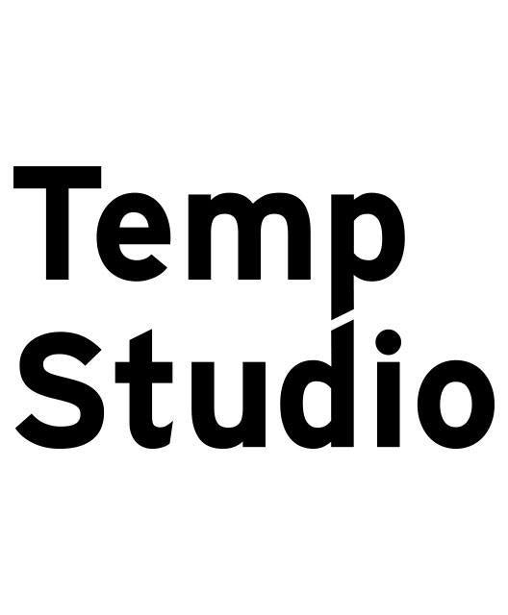
Entry form #2 Lisbon 2018

Personal Information

Name
Country
Age
Email
Phone

Project Information

Artist / collective name
Bio | 500 characters max.
Project title
Project abstract | 1000 characters max.
Keywords | e.g. AV Performance, VR, etc.
Techniques | e.g. Processing, Max/Msp, etc.)
Portfolio | 3 links max.

Accommodation

Yes
No

Since Temp Studio wants to provide a welcoming environment, we arrange accommodation for a limited number of participants. Please note that our conditions are modest. We will ask you to bring your own sleeping bag and be open to eventually share your space with other artists in residence.

Notes

- Call is open from February 1st to March 18th.
- We’ll be selecting a maximum of 20 artists.
- The participation fee is 130€, including studio rental, accommodation, lunch (7*days) and one official dinner party.
- Be aware that inscriptions are single-based even if you apply as a collective group.
- Temp Studio is a self-funded project so we can’t cover any production or travel expenses.
- Participants are selected based on their work and proposal.
- Once you submit your entry form we will contact as soon as possible informing you if your proposal was accepted so you can start planning your residence in Lisbon!
- Send this form by email to: info.tempstudio@gmail.com

